# Arduino LED Matrix NTP Clock

Download and install the Arduino IDE for Windows

<https://www.arduino.cc/en/Main/Software>

Launch the Arduino IDE and install the required libraries

Click Sketch > Include Library > Manage Library

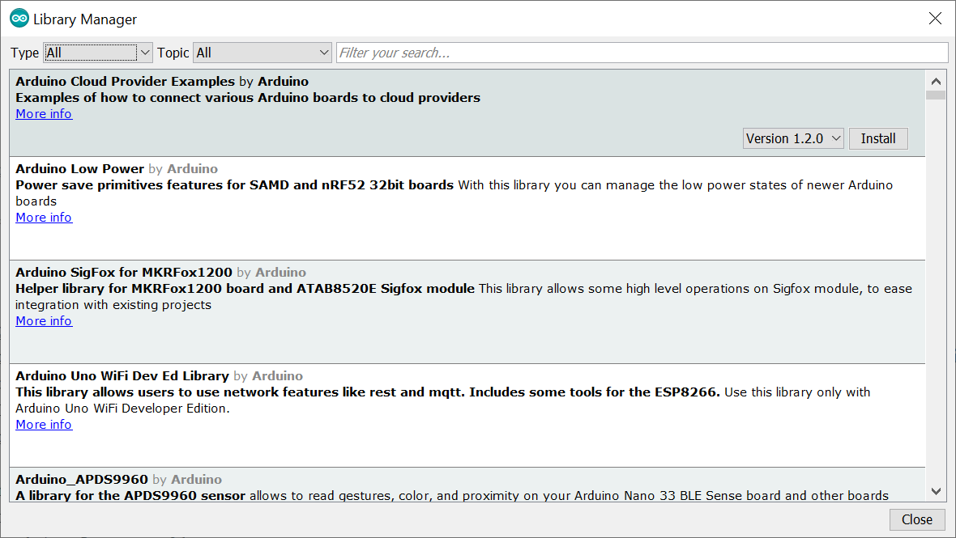

Search for the following libraries and install:

LedControl

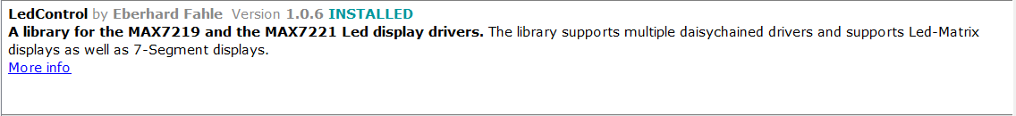

RTClib



Button.h

This one can’t be searched, head over to <https://github.com/tigoe/Button> and download it.

Once downloaded click Sketch > Include Library > Add .ZIP Library and point it to the file downloaded.

Adafruit Unified Sensor



Adafruit BME280



BH1750FVI



Install the following Additional board:

Click File > Preferences

Copy and paste the following into “Additional Boards Manager URLs”: <http://arduino.esp8266.com/stable/package_esp8266com_index.json> and click ok.

Click Tools > Boards > Boards Manager

Search and install “esp8266”

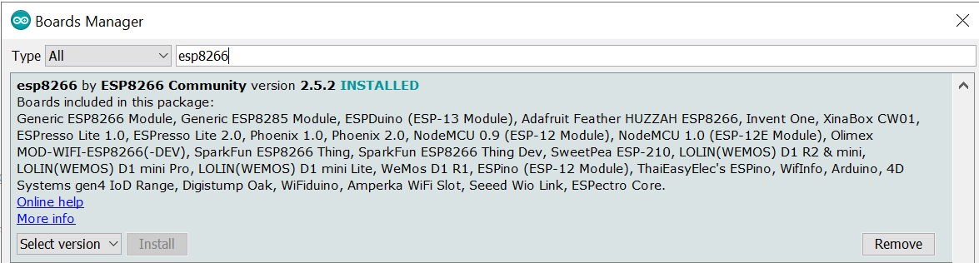

Head over to <https://github.com/Ratti3/miniclock> and click download

Open the .ZIP file and extract only the following folder to C:\Users\xx\Documents\Arduino\libraries

“FontLEDClock”

Create the following folder in C:\Users\xx\Documents\Arduino\Sketches

“LEDClock32x8_ESP01-NTP_LED-Switches”

Extract only these files to this folder:

“ESP-01_NTP.ino”

“LEDClock32x8_ESP01-NTP_LED-Switches.ino”

“ProgmemData.h”

Main Modes

|  |  |  |  |  |
| --- | --- | --- | --- | --- |
|  |  |  |  |  |

|  |  |  |  |  |
| --- | --- | --- | --- | --- |
|  |  |  |  |  |
|  |  |  |  |  |